Unit two

Refugee Week
Y3

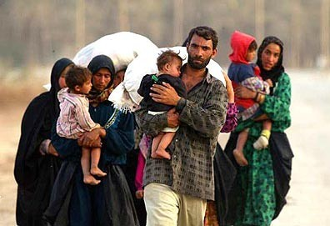

Developing the writing skills of
advanced EAL learners

Belmont Primary School, Harrow

Paula O’Hallaron & Lucy Banyard (Y3 teachers)
Alice Washbourne (Associate Consultant, The EAL Academy)
Refugee Week Resources Overview

Literacy objective: to write a diary extract

Success criteria:
- words to describe feelings and emotions
- descriptive vocabulary
- past tense verbs
- time connectives
- first person

RESOURCES | PUPIL ACTIVITY | TEACHER NOTES
1. Pictures of refugees and emotions words |  | Display pictures on learning wall for reference during the unit of work.
2. Pictures and labels | Pupils discuss which items they will take with them and why. | Teacher needs to collect as many of the real objects as possible attach labels and display in a suitcase as a visual stimulus. (Photos of the suitcase put together by the teachers at Belmont are included in this resource).  Teacher sets the scene:  It is an emergency. You must pack a bag and leave your home and country immediately. What will you take with you? You are only allowed 10 items.
3. Suitcase picture | Pupils write the names of chosen items on the suitcase.  Pupils discuss with a partner which items they will remove from their suitcase and draw a cross through the word. | Now tell pupils they are only allowed to take 6 items, so they have to remove 4.
4. Journey map | Think-pair-share ideas.  In pairs predict 6 words they will hear on the video. Write on mini-whiteboards.  As they watch tick any words from their list that they hear.  After watching sketch a map with words and pictures to show Hamid’s journey.  Add feelings words to the journey map in a different colour. Use the emotions pictures from the learning wall to help with vocabulary. | Introduce the word refugee.  Why might someone have to leave their home and country?  Tell pupils they will watch a video of one refugee boy’s journey.  Hamid’s journey video:  http://www.bbc.co.uk/learningzoneclips/seeking-refuge-hamid-s-journey-from-eritrea/13806.html
5. Model text beginning | Pupils respond to questions.  Talk partners discuss. | Introduce the model text. Ask:  What kind of text is it?  When was it written?  Who wrote it?  How do they feel?  Where are they?  Ask pupils to identify feelings, time, past tense, favourite description.  Teacher highlights these in different colours:  Red = feelings  Blue = time  Yellow = past tense  Green + favourite description  The purpose is to for pupils to understand the key features of the text type and use these as success criteria in their own writing later.
6. Diary extracts | Pupils underline the text in different colours for:  feelings, time, past tense, favourite description | Pupils now have a turn at identifying the features in the rest of extract 1 and extract 2 to reinforce learning.
7. Writing frame and sentence starters | (For pupils new to English only) | Most pupils will be able to write their own diary extract of a refugee using the model texts and success criteria.  Some pupils will find the sentence starters useful.  The writing frame is differentiation for pupils new to English only.

